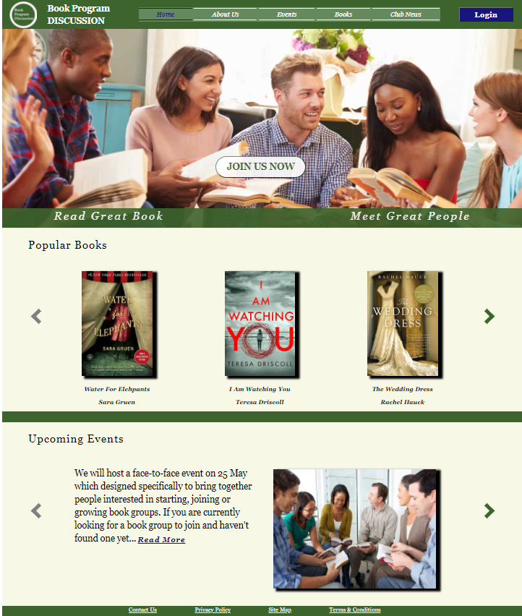

Assignment Two

Homepage & registration form design

Jinkai Zhang |Jzha541 | SOFTENG 350

# 1.0 INTRODUCTION

The design I chose was minimalist. All the features of the website are designed commonly. Users do not need to adapt to new complex components, which makes the website ease to use. Therefore, it has high efficiency and can quickly satisfy the needs of users. The prototype includes the homepage and registration form following the specified color style according to the customer's request. The website is designed in a width of 1440p, and the overall structure of the homepage is divided into four main sections from top to bottom:

* **Header** - Shows the name and logo of the book club, the navigation menu, and the login button.
* **Promotional Image** - Use images that match the campaign's content so that users can intuitively understand the situation, and the register button is placed in a prominent place inside the picture.
* **Popular Books** - Users can easily browse the latest popular books and decide if it suits their interests.
* **Activity Notification** - Inform the user of the following activities. Users can quickly get the club's activity information.

After the user clicks the "Join Us Now" button in the picture, the registration page will pop up after filling in the required information and clicks the "Submit" button to register successfully.

# 2.0 COLOR SCHEME

The color scheme of the website mainly chooses the following colors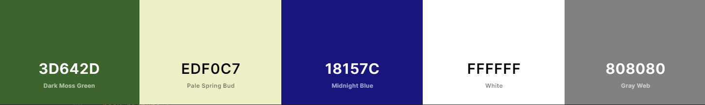:

Figure 1 Color Scheme

The overall style of the website uses the analogous color scheme, the olive green and light-yellow color palette to keep the look warm and straightforward, giving a feeling of nature. Use blue sparingly to add personality and emphasize the button's function while ensuring it does not interfere with the reading. The olive-green main user header and the dividing line in the middle distinguish the different sections. Light yellow is used as a background color for primary reading sections because it absorbs blue light and reduces eye strain.

The home page and the registration form have the same color scheme, which keeps the site consistent and makes users feel comfortable. Both pages have an olive-green header, a light-yellow main background, and a blue button in the upper right corner.

High contrast is used to distinguish between the navigation bar and the header of the website and different sections in the homepage. It also provides a strong readability for the text. This makes a good accessibility for users.

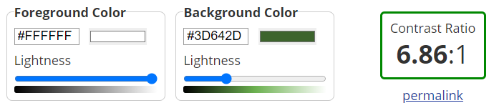

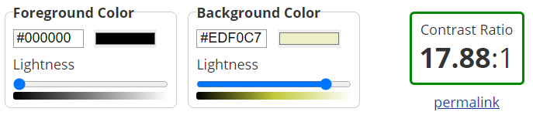Figure 2 Contrast Checker

Accessibility is very important for those who are visually impaired. For this, the Chrome extension [Colorblindly](https://chrome.google.com/webstore/detail/colorblindly/floniaahmccleoclneebhhmnjgdfijgg?hl=en) is used to ensure that all elements of the website are able to be read and distinguished. The test for Achromatopsia (Monochrome) and Tritanopia (Blue-Blind) is attached in the appendix.

# 3.0 FONTS

The usage of font is simple. We need a font that is simple and easy to read. The design decides to use Georgia fonts for readability, especially for the large section of text. Clear lines and sharp edges can be seen more clearly on the screen, which increases the user's legibility. Headings and subheadings are larger to create a sense of hierarchy. The italic and bold text is used to distinguish the title, as well as the button text to distinguish it as a button, with extra emphasis to inform the user that this is not plain text.

# 4.0 DESIGN PRINCIPLES

## 4.1 USER EXPERIENCE

To facilitate the use of new and old users. The navigation menu is placed at the top of the web page. Users can directly click the button to enter the desired page. Promotional images take up a large portion of the page to attract new users. When users first enter the page, they can quickly understand the services provided by the club based on the pictures and the slogans. The sign-up button is also placed prominently in the image for users to click on.

The book display section is intended to give the user the feeling of selecting a book on the shelf. Book photos with shadows provide a three-dimensional looking so that users feel more natural. The left and right arrows can be clicked to show more content. The color of the arrow lets the user know if there is more to come. The same design logic is used in the upcoming event section, so users can easily browse the club's current activity schedule.

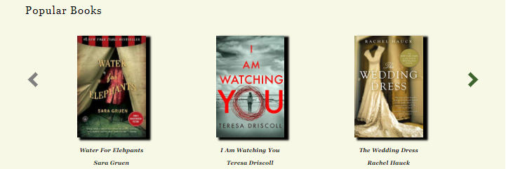

Figure 3 Popular Books Section

## 4.2 Gestalt principles

* The main page and sign-up page are designed following the **Symmetry principle**, on the main page symmetrically arranged around the "Join Us Now" button. In the Popular Book Section, books are placed in a row of three, one in the middle and two on both sides of the symmetrical arrangement. The Upcoming Events section on the home page adopts one side of the picture and the other of the text, which reflects a good balance. The input fields of the registration page are also symmetrically distributed around the "Submit" button. The Similarity/Symmetry Principle helps to 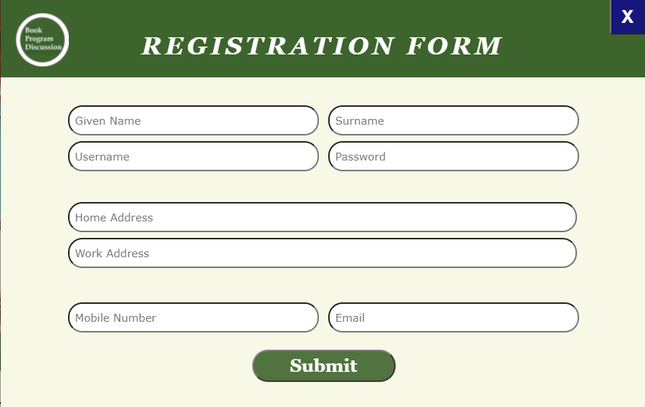create an aesthetically pleasing experience.

Figure 4 Registration Form

* The design of the website well follows the **Proximity Principle**. You can see this on the website's homepage, and there is a clear separation between headers, heroes, and content. In addition to the color grouping, the sections are spaced far apart from each other. To emphasize the grouping, an olive-green dividing line is used for separation.
* The design of the promotional image on the home page follows the **Area Principle**, using a significant image as a background and placing the promotional slogan and registration button in it. It makes the image compelling enough to attract the attention of potential users. The Upcoming Event Section's smaller image size allows users to focus more on the text.
* The user registration page adopts the **common fate principle**. All input fields are arranged neatly together. Users know exactly where to fill the information. The Proximity Principle and Similarity Principle are applied to distinguish different information types (the gap between User Details and Address, the length of the input field).
* The Popular Books Section adopts the **Similarity Principle**. All the books are displayed in a consistent format so that users naturally feel like they are in a horizontal row and click on the arrows to browse through more books. The same principle applies to navigation menus, where each button has the same design. Users can easily find and get the information.

## 4.3 Balance & EMphasis

Balance is reflected in the overall design of the site. On the home page and the registration page, most of the components are vertically centered and aligned. The rest components are evenly distributed on both sides. In the Upcoming Event section, text and images are on each side. As a result, it gives the impression that the components have the same vertical weight on both sides of the screen.

Use color contrasts and design inconsistencies to emphasize important information. Button in high contrast colors can be used to draw the user's attention. In the promotional image, this is used to emphasize the registration button. In the navigation menu, use different colors to emphasize the page the user is currently on.

## 4.4 Unity

The overall design of the website keeps a consistent style. We can find this in the color scheme for the home page and registration page. Both pages use the olive-green header and light-yellow background, and both have a blue button at the up-right corner. The use of fonts in web pages is also unified. This unified design will make users feel comfortable.

# 5.0 RESOURCES

## 5.1 Pictures:

**event_picture.jpg:** <https://www.signupgenius.com/church/church-icebreaker-questions-for-small-groups.cfm>

**main_picture,jpg:** https://www.shutterstock.com/image-photo/group-friends-taking-part-book-club-345816716

**popular_book_1.jpeg:** <https://www.pinterest.nz/pin/637400153490566003/>

**popular_book_2.jpg:** <https://topexperto.com/silent-chains/>

**popular_book_3.jpg:** <https://ar.pinterest.com/pin/407223991286837682/>

## 5.2 other:

**Modal Window pop-up function & close pop-up window function:**

https://www.w3schools.com/w3css/4/w3.css/

# 6.0 APPENDIX

## 6.1 Achromatopsia (Monochrome)

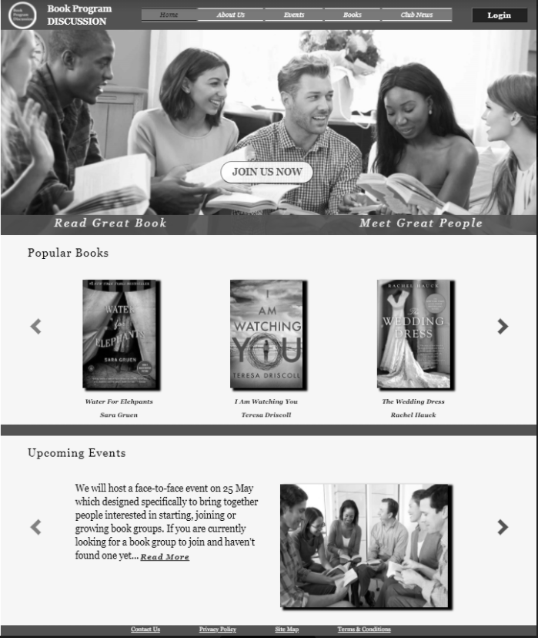

## 6.2 Tritanopia (Blue-Blind)

